A Python Synopsis on

**Grocery Management System**

Submitted to Manipal University Jaipur

Towards the partial fulfilment for the Award of the Degree of

**BACHELOR OF TECHNOLOGY**

In Computers Science and Engineering

2023-2027

By

Akshit Gupta  
23FE10CSE00454



Under the guidance of

**Mr. Jay Shankar Sharma**

______________________________   
Signature of Teacher  
 Department of Computer Science and Engineering

School of Computer Science and Engineering

Manipal University Jaipur

Jaipur, Rajasthan

**Introduction**

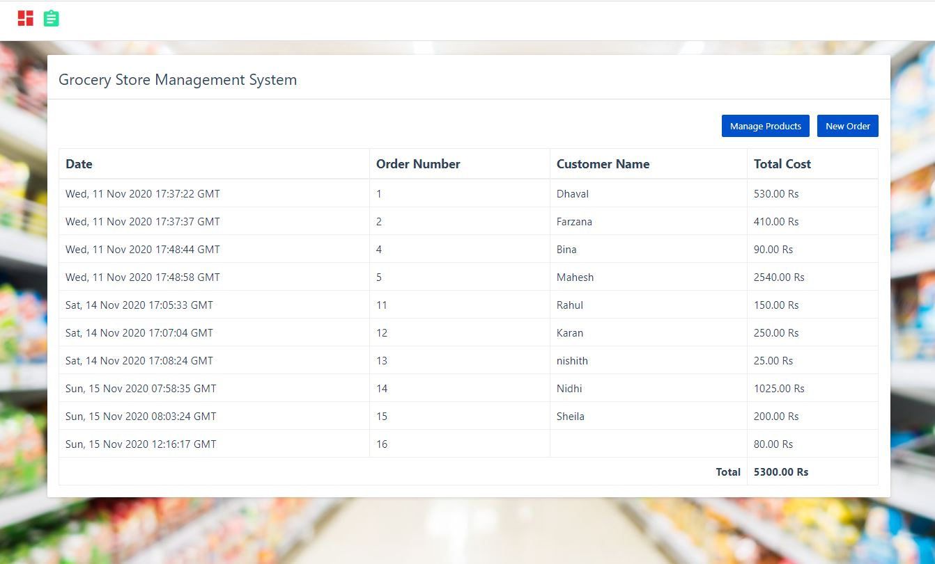The grocery store management system is a three-tier web application designed to serve as an e-commerce platform for purchases. This is an educational project, aimed at providing hands-on experience with full-stack development integrating Python (Flask), HTML/CSS, and MySQL. The program focuses on basic concepts such as user authentication, CRUD implementation, session management, etc., which enables students to understand real-world software development dynamics with this program, we aim to develop a functional system that connects users to grocery and allow basic cart operations without payment features.

The application follows the MVC (Model-View-Controller) design pattern. The MySQL database (Model) stores and manages the data, Flask (Controller) handles business logic, and HTML/CSS templates (View) present a user-friendly interface. By implementing this framework, the project ensures smooth data flow and system scalability, providing students with a technical approach to web application development.

**Journey of Making the Project**

The beginning of this project has been an enriching journey from concept to practical creation. The process began with the discovery of basic requirements such as user credentials, inventories, and shopping carts. Sketching UI mock-ups helped visualize the platform interface and guided the development process.

The initial phase focused on setting up the database schema in MySQL. Tables listing users, products, and cart content are created to support data persistence. Then, Flask was used to develop the backend, which included routing, session management, and integration with the database.

Equally important were the front-end improvements. HTML and CSS were used to create a responsive design, ensuring a seamless user experience on all devices. Jinja2 templating was used for dynamic content, making the pages interactive and visually appealing.

Regular testing at each level was critical. This redesign allowed for problems to be fixed and improved, ensuring that the application met its functional and aesthetic goals. Collaborating with peers and using open resources further enriched the learning experience.

**How I Made the Project**

* **Backend Development:** The backend was developed using Python and Flask framework. Flask’s lightweight nature and modularity made it an ideal choice for routing and handling user requests. It implemented user authentication, cart operations and data operations.
* **Database management:** MySQL served as the project’s database. It had tables for storing user credentials, product information, and cart information. SQL queries were added to Flask to easily retrieve and update data
* A blurry image of a store

  Description automatically generated**Frontend Development:** The frontend used HTML and CSS to create a visually appealing interface. Jinja2 successfully provided dynamic features such as product listings and cart summaries. Bootstrap components were also included for consistency and design.
* **Integration and testing:** Flask connected the front end to the back end, enabling real-time data updates. Testing focused on ensuring that features such as logging in, adding items to carts, and meeting management worked flawlessly.

**Software’s Used**

1. **Flask:** For routing, user authentication, and server-side logic.
2. **Jinja2:** Render dynamic HTML templates.
3. **MySQL Connector/PyMySQL:** For connecting Flask with the MySQL database.

**Conclusion**

This grocery store management systems project provided a comprehensive learning experience in developing accuracy. It served as a platform for understanding how various parts of the web application work together, from the backend logic to the frontend interface and database integration.

This internship gave me valuable knowledge in Flask, MySQL, HTML, and CSS by learning practical application development. Although simplified by excluding payment products, this work lays a solid foundation for building more advanced e-commerce systems in the future. The hands-on experience here prepares me to take on the biggest challenges in software development and contribute to real-world projects effectively.

This journey has been more than just coding—it is a process of learning, maintaining, and building confidence as a developer. With this project completed, I am excited to explore more opportunities to create impactful applications.

**Repository Link**

* [**https://github.com/AkshitGupta0225/Python-Lab-Course.git**](https://github.com/AkshitGupta0225/Python-Lab-Course.git)
* [**https://github.com/AkshitGupta0225/Python-Mini-Project.git**](https://github.com/AkshitGupta0225/Python-Mini-Project.git)